Name:_____________________________________ Score:
Section:_____________________ Date: _________

WORKSHEET No.1
Topic: Waves

- What is a wave?

- What is a medium?

- Distinguish mechanical waves from electromagnetic waves.

- What are the types of waves according to the motion of the particles of the medium?

- What is wave pulse?

- Differentiate compression/condensation from rarefaction of longitudinal wave.

- Explain the mechanism of energy transfer in waves.

- How the elasticity of the medium is affects the propagation of waves?

Name:_____________________________________ Score:
Section:_____________________ Date: _________

WORKSHEET No.2

Topic : Measure of a Wave

- Label the parts of the transverse and longitudinal waves below.

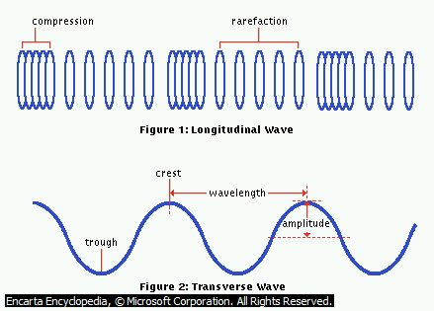

- Describe the following measures of a wave.

- Period

- Frequency

- Amplitude

- What is wavelength?

Name:_____________________________________ Score:
Section:_____________________ Date: _________

WORKSHEET No.3

Topic: Speed of a Wave

Solve for the following problems completely

- Sound waves are longitudinal waves in air. The speed of sound depends on temperature; at 20 ⁰ C it is 344 m/s (1130 ft/s). What is the wavelength of a sound wave in air at 20 ⁰ C if the frequency is 262 Hz?

- The linear mass density of clothesline is 0.250 kg/m. a) how much tension does Trixie have to apply to produce the observed wave speed of 12.0 m/s? b) if the tension is increased to four times the value in (a) but the frequency still 2.00 Hz, what will be the wavelength of the wave on the clothesline?

- With what tension must a rope with a length 2.50 m and mass of 0.120 kg be stretched for transverse waves of frequency 40.0 Hz to have a wavelength of 0.750 m?

I
- Find the Young’ modulus of elasticity for a bone if its specific gravity is 2.0 and the velocity of sound in the bone is 2.8 x 10³ m/s.

- What is the velocity of the wave in a guitar string having a length of 0.65m and a mass of 3.5 g when subjected to a tension of 250 N?

Name:_____________________________________ Score:
Section:_____________________ Date: _________

WORKSHEET No.4
Topic: Standing Waves
Answer the following:
- What is standing wave?

- How standing wave is produced?

- What is (a) node?

(b) antinode?

- Describe harmonic of wave?

- Using the illustration below, complete the asked informations.

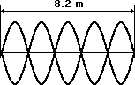

- No. of nodes
- No. of antinodes
- Harmonic
- No. of loops/segment
- Length-wavelength relationship

Solve for the following completely. Box your final answer.
- What is the wavelength of sound waves produced in the air when the string is vibrating at its fundamental frequency of 20 Hz? The speed of sound in air at 20⁰C is 344 m/s?

- A piano tuner stretches a steel piano wire with a tension of 800 N. The steel wire is 0.400 m long and has a mass of 3.0 g. (a) what is the frequency of its fundamental mode of vibration? (b) What is the number of the highest harmonic that could be heard by a person who is capable of hearing frequencies up to 10, 000 Hz?

- If the fundamental frequency of a wave is 330Hz, what is the frequency of the fifth harmonic and the second overtone?

- A 10-g string, 4m in length, has a tension of 64 N. What is the frequency of its fundamental mode of vibration? What are the frequencies of the first and second overtones?

- A 0.500-g string is 4.3 m long and has a tension of 300 N. If it is fixed at each end and vibrates in three segments, what is the frequency of standing waves?

