Table 1

1. 2.



Table 2

3-6. Eight students are in front of a 1 square meter mirror. Their positions are shown in the diagram below. Make appropriate constructions to answer the following:

mirror

O O O O O O O O

An Bev Cy Ela Ferdz Jang Joy Tet

1. Who can An see? _______________________
2. Who can Bev see? _______________________
3. Who can Cy see? ________________________

Table 3

7. A light ray travels from water (n = 1.33) to glass (n = 1.52) at an angle of incidence 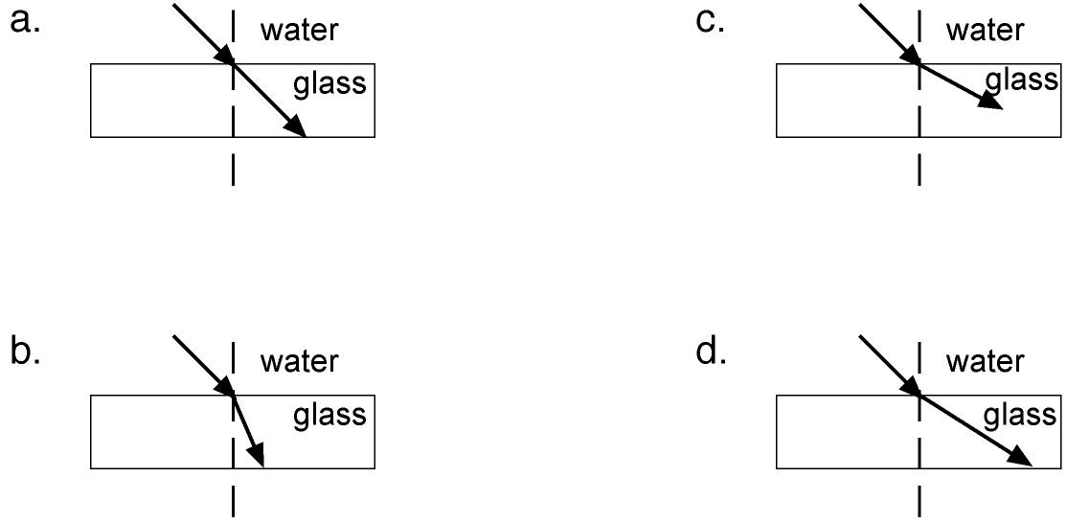other than 90°. Which of the following shows the path of the light ray?

8-9.What are the two main types of lenses?

Table 4

10. The____________itself makes small focusing adjustments. It doesn’t move backwards or forwards like the lens in a camera or projector. Instead it becomes thinner or fatter.

11. The ___________ is the ‘screen’ which detects the image. It contains millions of tiny cells which are sensitive to light. The cells send signals along the optic nerve to the brain.

12. The ___________ gives you an upright view of the world. But it isn’t always the same as the image in your eye.

Table 5

13-14. An ___________ is a device used to measure current at a point in the circuit while a _________ is a device used to measure potential difference or voltage between two points in a circuit.

15. Ohm’s law states that the ratio of voltage to current in a material is a constant. This constant is the resistance of the material. That is, R = V/I

Table 6

16. The SI unit of magnetic flux is ____________.

17. The measure of ability to establish magnetic flux is called ______________.

18. The end pointing toward the earth’s south magnetic pole is the ________________ of the magnet.

19. Materials with a relative permeability slightly less than unity have the property of being repelled by a strong magnet. Such materials are said to be _____________.

**A.Table 1**

Describe the image formed on the following;

|  |  |  |  |
| --- | --- | --- | --- |
| **Optical lens** | **Nature** | **Position** | **Size** |
| 1-3.camera |  |  |  |
| 4-6.eye |  |  |  |
| 7-9. microscope  ( objective) |  |  |  |

A. Table 2

10. Which of the diagrams in the figure below could represent the path of light ray through a glass block in air?

a.A c. B

c. C d.D

A B C D

11. What type of reflection is illustrated in the figure below?

12. A __________ cannot be picked up on a screen because the rays do not pass through it. It is the place where the rays appear to come from.

Table 3

13. ____________are images which are formed in locations where light does not actually reach. Light does not actually pass through the location on the other side of the mirror; it only appears to an observer as though the light is coming from this location.

14. The resistance of a conductor is proportional to its length and inversely proportional to the cross sectional area of the conductor. It is measured in ohms by an ohmmeter.

15. A short circuit takes place when current passes through a shortened path in the circuit due to the crossing or touching of uncovered portions of the wire. Here, electrons flow through portions of very low resistance in a circuit instead of passing through useful loads.

Table 4

16-19. Determine the direction of the missing value.

Variable Direction

16) F Up

B Out

**I ?**

17) F In

B Right

**v** ?

18) F Left

B Up

**I ?**

***Table 1***

1. A resistors first three color bands are green, black and red. What is its value?

2. Which digits does the color violet in resistor color band?

 3. A 25 kὩ resistor would have which colors on its first 3 bands?

 4. Which tolerance level does the color gold on a resistor color band?

***Table 2***

 5. As the wavelength of a wave in a uniform medium increases, its frequency will _____.

|  |  |  |
| --- | --- | --- |
| a. decrease | b. increase | c. remain the same |

6. The speed of a wave depends upon (i.e., is causally affected by)

a. the properties of the medium through which the wave travels

b. the wavelength of the wave.

c. the frequency of the wave.

7. The shortest distance between peaks, the highest points, and

troughs, the lowest points, is the

* 1. Period
  2. Amplitude
  3. Frequency
  4. Others: specify

*Table 3*

*Identify the parts of the standing waves.*

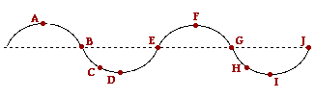

8. Points A and F is the ____________________________.of the standing wave.

9. Points and B, E, G, and J is the _____________________ of the standing wave

10. Points D and I is the _______________ of the wave.

Table 4

11. The further apart two magnets are from one another the stronger the forces that attract or repel the magnets.

 True  False

12. When magnets are broken into small bits, the bits themselves can become small magnets.

 True  False

13. Naturally occurring magnets in nature are called

 plastics  stones  lodestones

14. Which of these is not used to create a simple electromagnet?

 battery  bulb  copper wire

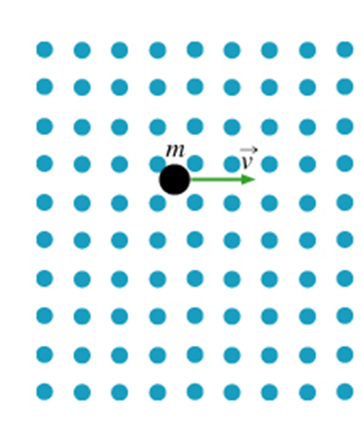

**Table 5**

15-16.Indicate the direction of the field.

17. What type of particle is A?

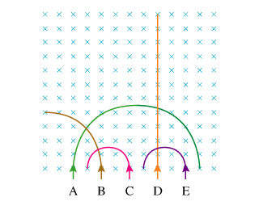

**18.** What is the direction of the magnetic force on acting on the proton?

