A. Table 1
1. The perpendicular to where light hits a substance is called____________.
 | 2. | In a ray tracing diagram, two rays must pass through the __________ to determine the location of the image.

 | 3. | What does the F on a ray diagram represent?

 | 4. | A __________ image is formed when light rays converge and pass through the image.

A. Table 2
5. A French physicist who discovered radioactivity through his investigations of uranium and other substances on the 24th of February 1896. In 1903 he shared the Nobel Prize for Physics with Pierre and Marie Curie.

6. What does hazard symbol below mean?

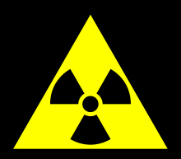

7. The illustration below is an example of what radioactive decay?

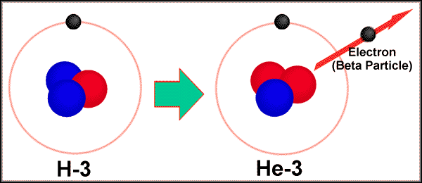

8. Which of the types of radiation has the greatest ability to penetrate matter?
9. What optical aids is used to reduce the glare of light through the concept of polarization?
10. A / An is a medical device consisting of a long, thin, flexible (or rigid) tube which has a light and a video camera.

A.Table 3
Describe the image formed on the following;
Optical lens | Nature | Position | Size
11.camera
12.eye

13. microscope
( objective)

A.Table 4

14. If Suzie stands 3 feet in front of a plane mirror, how far from the person will her image be located?
15. ____________are images which are formed in locations where light does not actually reach. Light does not actually pass through the location on the other side of the mirror; it only appears to an observer as though the light is coming from this location.

A.Table 5

16. ________________states that "the image is always the same distance behind the mirror as the object is in front of the mirror."
17. __________ occurs when multiple images formed.

B.Table 1
1. Particles of matter that have no mass and always move at the constant speed of about 300,000 km/sec (186,000 mi/sec) when they are in a vacuum.
2-3. The propagation of light is best described by a (2)________, but understanding emission and absorption requires a (3) __________approach.

B.Table 2
4. Reflection at a definite angle from a very smooth surface is called _________.
5. The reference line used for measuring angles is a line that is perpendicular to the surface. The line is called ______________.

B.Table 3
Optical lens | Nature | Position | Size
5. Eye
6. LCD projector

7. microscope
( eyepiece)

B.Table 4
8. On hot day, the far end of the road appears wet. Light bends above the pavement because hot air has a lower index of refraction than cooler air. This phenomenon is called_____________.
9. __________ is the distance from the vertex to the center of curvature.

B.Table 5
10. Describe the imaged formed on the ray diagram below.
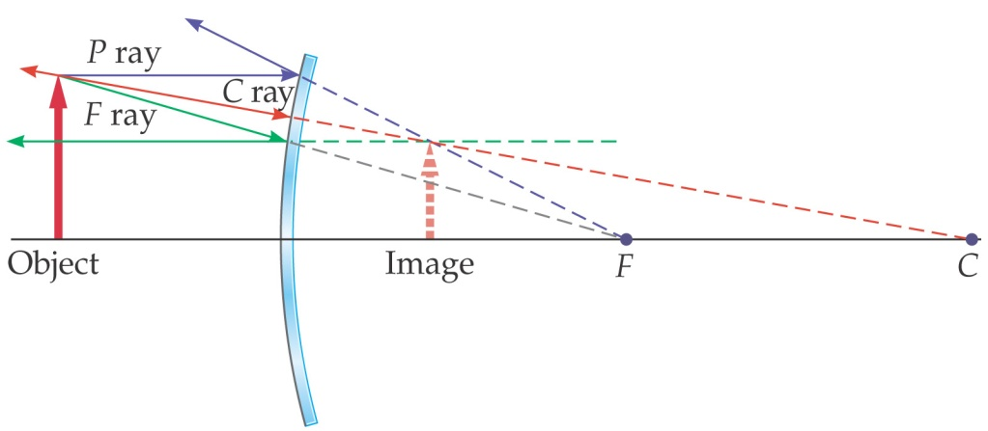
11. Describe the imaged formed on the ray diagram below.

12. A French physicist who discovered radioactivity through his investigations of uranium and other substances on the 24th of February 1896. In 1903 he shared the Nobel Prize for Physics with Pierre and Marie Curie.

13. What does hazard symbol below mean?

14. The illustration below is an example of what radioactive decay?

16. Which of the types of radiation has the greatest ability to penetrate matter?

17. What optical aids is used to reduce the glare of light through the concept of polarization?

C.Table 1
True or False
(1) The image of an object placed in front of a concave mirror is always upright. (2) The height of the image of an object placed in front of a concave mirror must be smaller than or equal to the height of the object.
(3) The image of an object placed in front of a convex mirror is always upright and smaller than the object.

C.Table 2
(4) The focal length f of a converging lens is considered
a. positive
b. negative
(5) The radius of curvature (either R₁ or R₂) of the surface that is curved inward is
a. positive
b. negative

C.Table 3
Optical lens | Nature | Position | Size
6. Microscope (objective)
7. LCD projector

8. microscope
( eyepiece)

C.Table 4

8. The nature of the image formed by a convex mirror does not depend on the position of the object. It is always _______________________.

9. A __________ cannot be picked up on a screen because the rays do not pass through it. It is the place where the rays appear to come from.

C.Table 5

10. Describe the image that will form on the ray diagram below.

C F
11. Describe the imaged formed on the ray diagram below.

12. A French physicist who discovered radioactivity through his investigations of uranium and other substances on the 24th of February 1896. In 1903 he shared the Nobel Prize for Physics with Pierre and Marie Curie.

13. What does hazard symbol below mean?

14. The illustration below is an example of what radioactive decay?

15. Which of the types of radiation has the greatest ability to penetrate matter?

16. What optical aids is used to reduce the glare of light through the concept of polarization?

17. A / An is a medical device consisting of a long, thin, flexible (or rigid) tube which has a light and a video camera.

D.Table 1
1. A French physicist who discovered radioactivity through his investigations of uranium and other substances on the 24th of February 1896. In 1903 he shared the Nobel Prize for Physics with Pierre and Marie Curie.

2. What does hazard symbol below mean?

3. The illustration below is an example of what radioactive decay?

4. Which of the types of radiation has the greatest ability to penetrate matter?

5. What optical aids is used to reduce the glare of light through the concept of polarization?

6. A / An is a medical device consisting of a long, thin, flexible (or rigid) tube which has a light and a video camera.
7. Which of the diagrams in the figure below could represent the path of light ray through a glass block in air?
a.A c. B
c. C d.D
A B C D

8. What type of reflection is illustrated in the figure below?

D.Table 2

9. The scientist who proposed the corpuscle theory of light was _________.
10. What is f if you have an object 2.0 m from the concave mirror, and the image is 4.0 m from the mirror?

D.Table 3
Optical lens | Nature | Position | Size
11. Microscope (objective)
12. LCD projector

13. eye

D.Table 4
Determine the (14) nature, and (15) orientation and (16) size of the image formed on the figure below using ray diagram.

F F

17. What vision defect results from too short focal length, resulting in the image falling in front the retina?

1. A French physicist who discovered radioactivity through his investigations of uranium and other substances on the 24th of February 1896. In 1903 he shared the Nobel Prize for Physics with Pierre and Marie Curie.

2. What does hazard symbol below mean?

3. The illustration below is an example of what radioactive decay?

4. Which of the types of radiation has the greatest ability to penetrate matter?

5. What optical aids is used to reduce the glare of light through the concept of polarization?

6. A / An is a medical device consisting of a long, thin, flexible (or rigid) tube which has a light and a video camera.

